Awal semester..semangat baru juga

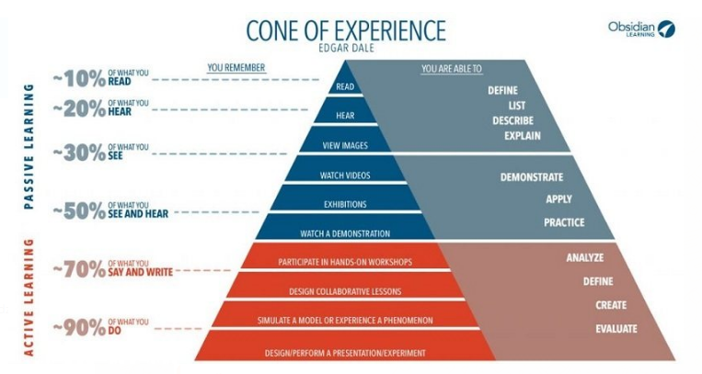

(Source: <https://elearningindustry.com>)

<http://dikti.go.id/microcredential-ai/> pelatihan

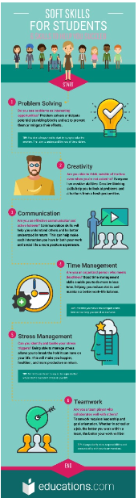 

1. (Source: <https://id.educations.com/articles-and-advice/soft-skills-you-need-to-get-ahead-14193>)
2. (<https://charactercounts.org/character-counts-overview/six-pillars/>) sejalan dg pendidikan karakter di UTM (APiK : Amanah, Peduli dan Kreatif).

Keduanya harus dipraktekkan sehari2.

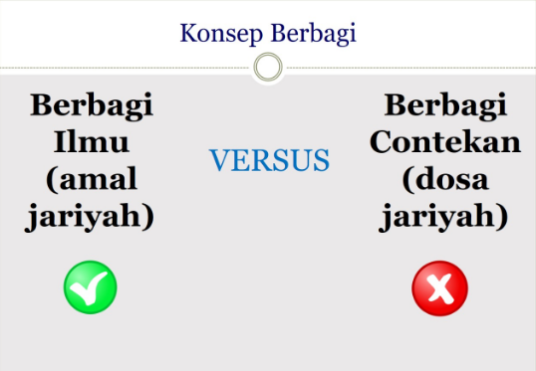

Kontrak Kuliah Struktur Data

Kuliah mulai jam 07.00-09.15 (maks keterlambatan 10 menit)

Wajib on Camera saat daring, mute speaker kecuali jika diperlukan boleh unmute.

Penilaian:

|  |  |  |  |  |
| --- | --- | --- | --- | --- |
| Kehadiran | Keaktifan | Praktikum | UTS | UAS |

Nilai Akhir=(15%*D11)+(10%*E11)+(20%*F11)+(25%*G11)+(30%*H11)

NilaiHuruf=IF(I11>=80;"A";IF(I11>75;"B+";IF(I11>70;"B";IF(I11>65;"C+";IF(I11>55;"C";IF(I11>50;"D+";IF(I11>40;"D";"E")))))))

